**Add New page of Test data upload**

This page should be displayed before Execution page

Accessible for Company User, Administrator and Tester users

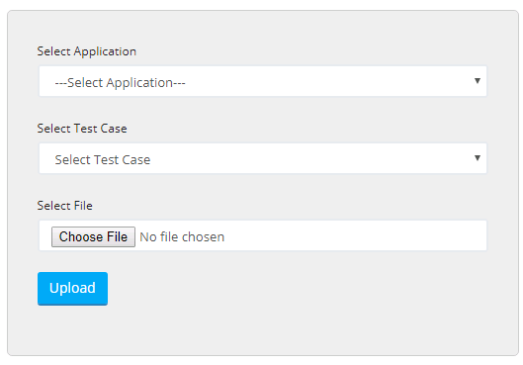

**Number of Failed Attempts**

1. There should a dropdown field on Execution Page with 1, 2, 3, 4, 5 values
2. Consider user selected 68 test cases for execution and trigger the execution with 3 filed attempt
3. If out of 68 consider 3 test cases failed because of some reason so it will create

<RUN_NAME Eg: Administrator User Executes All> folder under

F:\SeleniumAutomation_V1\test-output\

1. There will be testng-failed.xml file generated with 3 failed cases data
2. Move this file to F:\SeleniumAutomation_V1
3. Rename this file to TestNGExecutor.xml
4. Rename below line

<suite name="Failed suite [Administrator User Executes All]">

<test name="Administrator User Executes All(failed)">

To

<suite name="Administrator User Executes All Run 1">

<test name="Administrator User Executes All Run 1">

1. Trigger the batch file
2. If there are still 2 failure then this loop continues from Step 3

In this case Folder name will be

<RUN_NAME Eg: Administrator User Executes All Run 1> folder under

F:\SeleniumAutomation_V1\test-output\

Continue Step 4, 5, 6, 7, 8

Highlighted lines are part of loop which is iterated by value selected in

“No. of Failed Attempt”

**Bucket Concept**

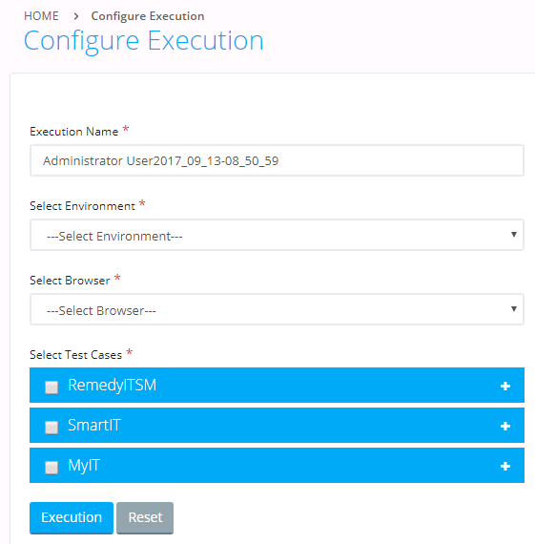

**Saving logical Group**

1. Include a Checkbox above Execute button names “Save Logical Group”
2. If user select “Save Logical Group” then there should be a text field appear next to the checkbox for Entering Logical Name and button to submit
3. Once user click on Submit button, text field and Submit button gets hidden, so that user can make another logical group
4. On Submit :

Columns in Database

1. Logical group name
2. Environment id
3. Test Cases id
4. Created by <Logged in user name>
5. Created Email
6. Created on
7. Company Id

**~~Executing logical group with modifications~~**

1. ~~Include Radio button above Execution name~~
2. ~~Configure Execution~~
3. ~~Execute Logical Group~~
4. ~~If user Select “a. Configure Execution” then It will use current implementation~~
5. ~~If user select “b. Execute Logical Group”~~

* ~~There will a drop down before Execution Name which will list down all saved logical group~~
* ~~When user selects any logical group then based on that~~

~~Environment field, Browse field, No of failed attempt field and test cases gets selected~~

* ~~With this user can change the Environment or Browser or no of failed attempt or test cases based on his requirement and execute~~

**Executing Logical group as it is:**

1. Create new Page “Execute Logical Groups” which should look like Report page

Text Field for “Execution Name”

Columns should be

1. Checkbox
2. Logical Group name <Editable>
3. Environment
4. ~~Browser~~
5. ~~No of Test cases included~~
6. Created on
7. Created by
8. Action Column (View, Delete, Clone)
9. Execute button should be there on the page
10. When user click on View button then summary should be shown in popup window
11. When user click on Delete button then Logical Group should get deleted
12. When user click on Execute button then there should be Test NGExecutor.xml generated at

F:\SeleniumAutomation_V1\

And Batch file should get trigger